
Story

Date | 29 July 2026
Team ID | OBUVARSHINI O
Project Name | GLOBAL AI EDUCATION
Maximum Marks | 5 Marks

Activity 1: Story Design:

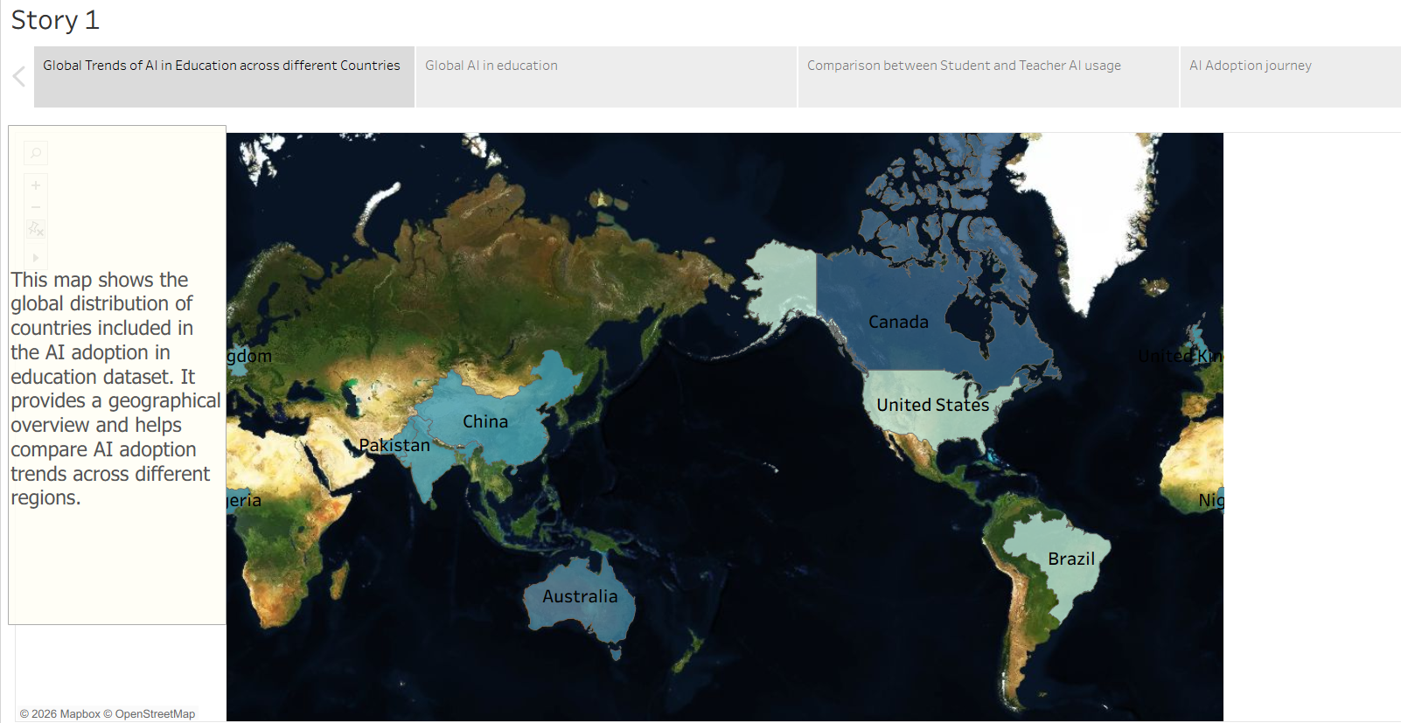

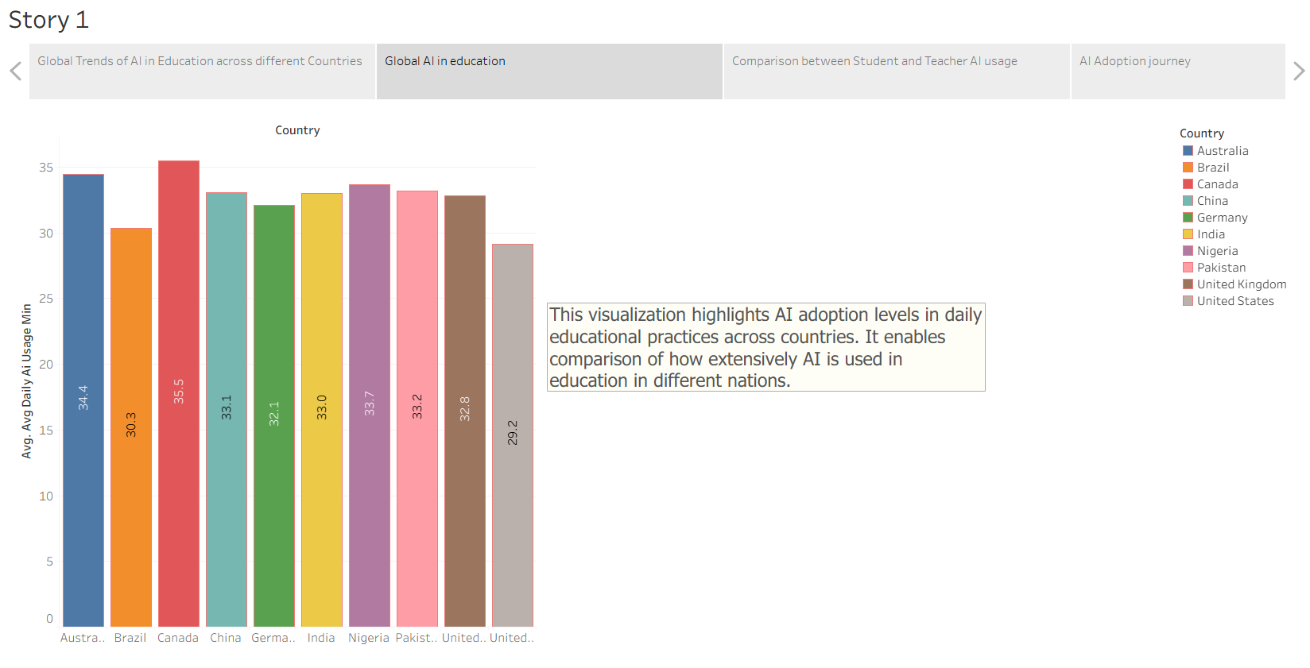
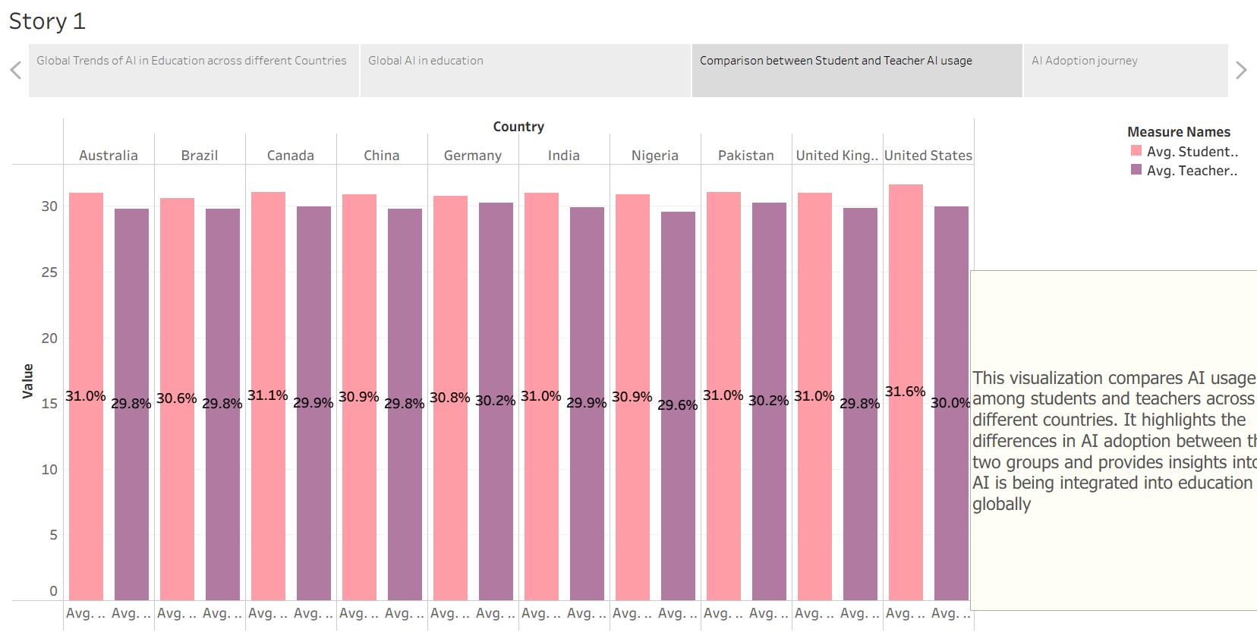
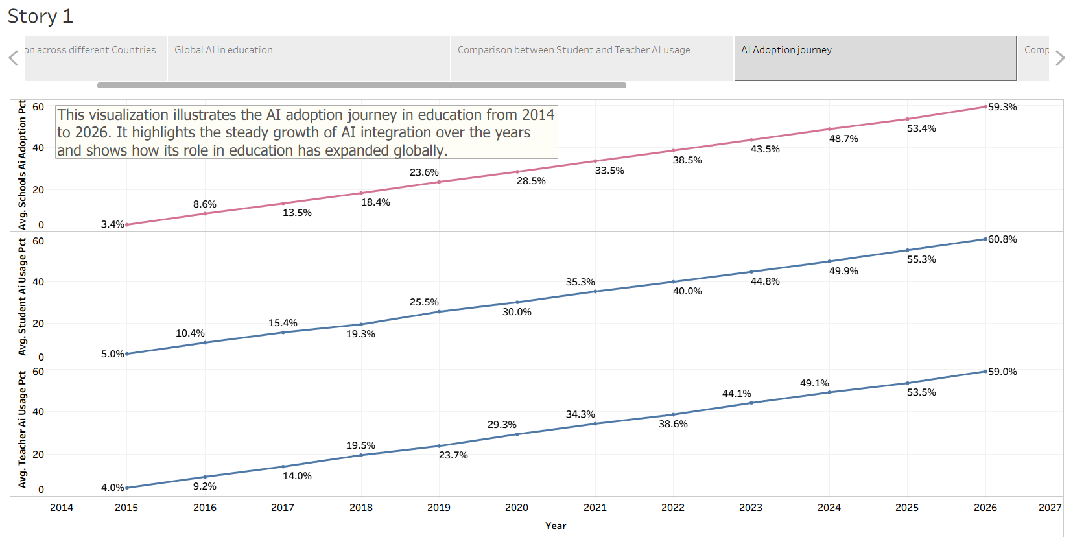
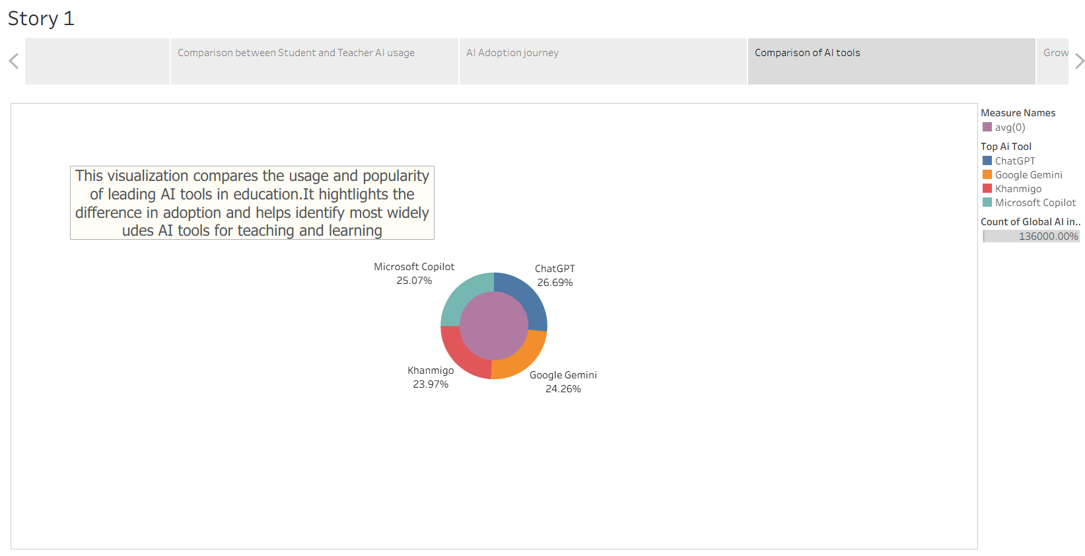
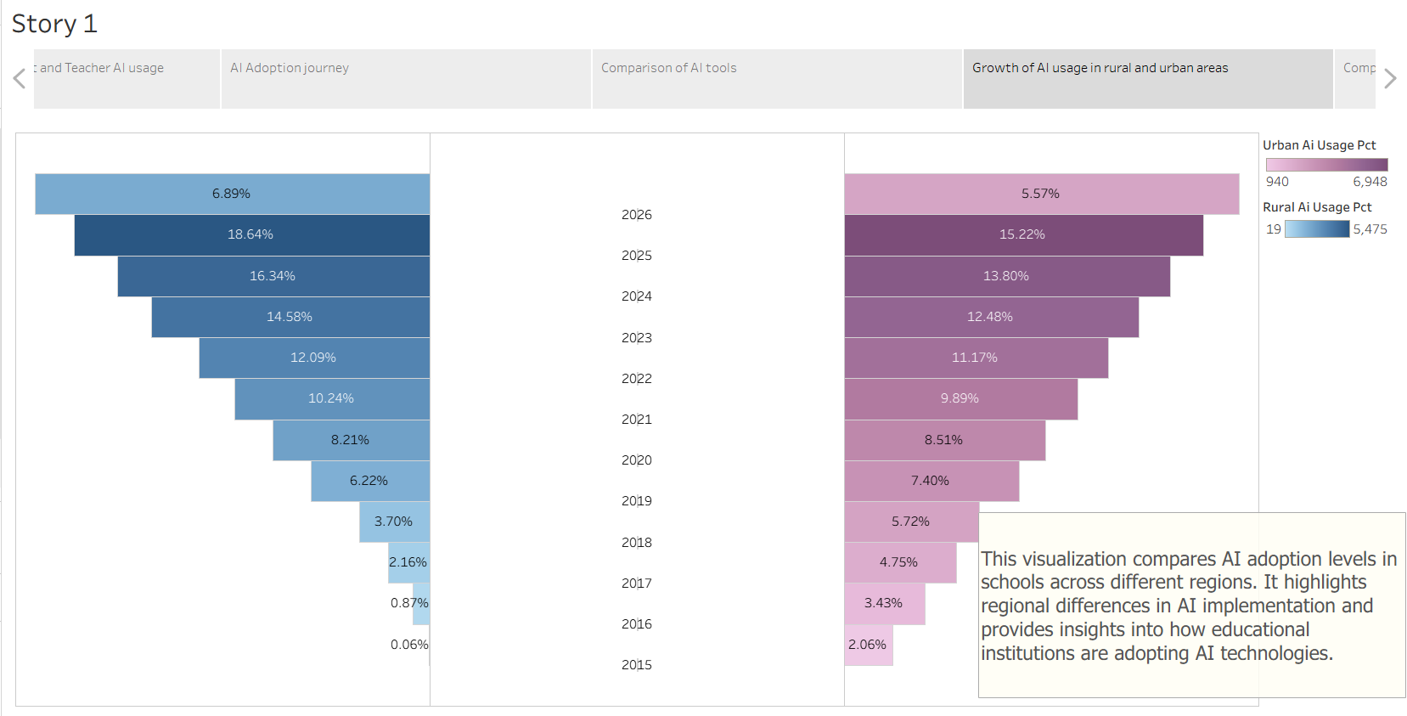

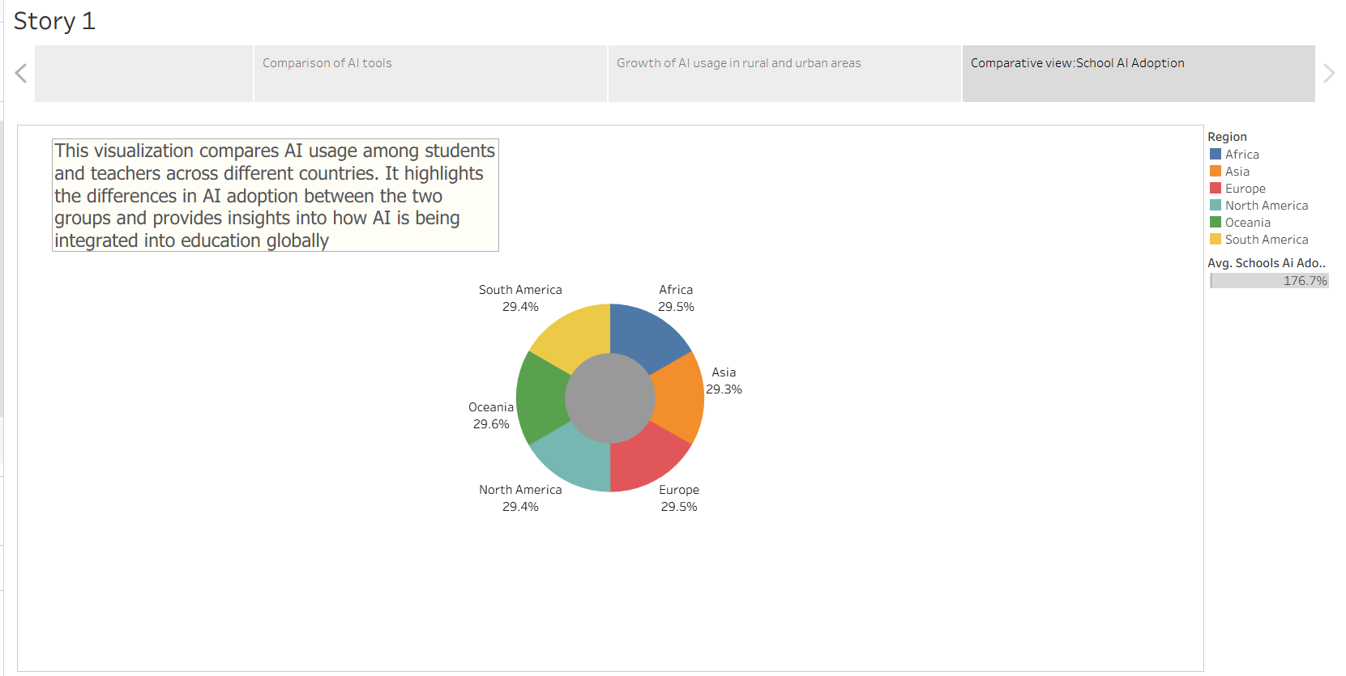

Activity 1: Story Design

Tableau Story Narrative & Observations
By leveraging the sequential story point structure in Tableau, the Global AI Education Analytics Story guides educators, policymakers, and researchers through a comprehensive journey of AI adoption in education. The story transforms educational data into meaningful insights about how AI is reshaping learning and teaching worldwide.
Rapid Growth of AI Adoption in Education
The AI Adoption Journey visualization reveals a consistent rise in school AI adoption, student AI usage, and teacher AI usage from 2015 to 2026. This demonstrates the increasing integration of AI technologies into educational environments across the globe.
Student-Led AI Adoption Trends
The comparison between student and teacher AI usage shows that students generally adopt AI tools at a slightly higher rate than teachers. This indicates that learners are often early adopters of emerging educational technologies.
Global Expansion of AI in Schools The geographical and regional visualizations illustrate that AI adoption is occurring across multiple continents and countries. The balanced distribution highlights that AI-powered education is becoming a worldwide movement rather than being limited to a few developed regions.
Growing AI Accessibility in Rural and Urban Areas
The rural and urban growth analysis demonstrates a steady increase in AI usage across both communities. Although urban areas initially showed higher adoption rates, rural regions are rapidly catching up, helping reduce educational technology gaps.
Diverse AI Tool Utilization
The AI tools comparison highlights the widespread use of platforms such as ChatGPT, Google Gemini, Microsoft Copilot, and Khanmigo. The relatively balanced usage indicates that educational institutions are exploring multiple AI solutions to support teaching and learning.
Variations in Daily AI Usage Across Countries
The country-level analysis shows differences in average daily AI usage among nations. Some countries demonstrate higher engagement with AI-powered learning tools, providing valuable insights into global educational technology readiness.

Activity 2

Publish Story on Tableau Public and Paste Public Link Below
Tableau Public Story Link:
https://public.tableau.com/app/profile/obuvarshini.o7003/viz/tableauproject1workbook/Story1?publish=yes
https://public.tableau.com/app/profile/obuvarshini.o7003/viz/tableauproject1Story/Story1?publish=yes

